COMP4801: Final Year Project

**Final Report**

**Smart Pantry: A Mobile Application for Inventory and Nutrition Intake Management**

Project Supervisor:

**Prof. Hengshuang, Zhao**

Student:

**Pratik Bhattacharjee (UID: 3035767425)**

Date of Submission: 21st April 2025

## Abstract

Food waste remains one of the most urgent sustainability challenges worldwide, with households contributing over 60% of the total volume discarded annually. In Hong Kong, this figure is even more alarming—households account for approximately 65% of the city’s food waste, translating into thousands of tonnes sent to landfills every day. Despite growing awareness, the problem persists largely due to busy urban lifestyles, poor planning, confusion over expiry dates, and the absence of accessible tools for effective pantry management.

This project introduces Santry, a cross-platform mobile application aimed at empowering individuals to reduce household food waste through smart inventory tracking and behavioural nudging. The application streamlines food item entry via voice commands and grocery receipt scanning using OCR, predicts expiry dates using AI, and generates personalized recipe suggestions based on the user’s inventory. It also includes a dish scanning feature that provides nutritional feedback, supporting healthier and more mindful consumption.

Built using React Native and powered by a Django REST API hosted on AWS, Santry employs asynchronous processing through Celery, integrates AI services such as AWS Textract and DeepSeek, and stores media securely in Amazon S3. The system is designed for scalability, low-latency performance, and cross-platform compatibility.

The final prototype demonstrates strong functionality and a cohesive user experience across its features. While limitations—such as cloud latency and reduced recognition accuracy for regional dishes—still exist, the architecture supports future enhancements including localized AI models and regional server deployment.

Santry addresses a critical market gap by offering a practical, culturally relevant, and user-friendly digital tool to combat food waste at its root: the household. It represents a scalable, real-world solution that aligns with global sustainability targets such as SDG 12.3 and promotes long-term behavioural change in food consumption.

## Acknowledgement

I would like to express my sincere gratitude to **Dr. Hengshuang Zhao**, my supervisor, for his invaluable guidance, encouragement, and support throughout the development of this final year project. His insights and feedback were instrumental in shaping the direction and quality of my work.

I am also thankful to the **Department of Computer Science at The University of Hong Kong** for providing the resources and academic environment that enabled me to undertake this project.

Finally, I would like to extend my deepest appreciation to **my parents**, whose unwavering support, patience, and belief in me have been the foundation of my academic journey. Their encouragement has been a constant source of strength throughout this process.

Table of Contents

Abstract ii

Acknowledgement iii

List of Tables vi

List of Figures vii

Abbreviations ix

1. Introduction 1

1.1 Project Background 1

1.2 Project Objectives and Motivation 3

1.3 Project Deliverables 4

Cross-Platform Mobile Application 5

Smart Inventory Management 5

Expiry Prediction and Notifications 5

Recipe Suggestion Engine 6

Nutritional Information via Dish Scanning 6

User Management and Profile Personalization 6

1.4 Report Outline 7

2. Literature Review 9

2.1 Current Approaches and Initiatives for Food Waste Reduction 9

2.1.1 HKSAR Government Initiatives 9

2.1.2 Corporate and NGO Initiatives 10

2.2 Technology Solutions for Household Food Reduction 10

2.2.1 Around the World 10

2.2.2 In Hong Kong 11

2.3 Gap in the existing market and the need for Santry 11

3. Methodology 13

3.1 Prototype-Driven Development Approach 13

3.2 System Architecture and Component Responsibilities 15

3.2.1 Mobile Front-end Technologies 15

3.2.2 Authentication Server 16

3.2.3 Backend Server and Container Management 16

3.2.4 Database Layer 17

3.2.5 Asynchronous Task Processing 17

3.2.6 Cloud File Storage 17

3.2.7 AI Service Integration 18

3.3 Feature Workflow – A Deep Dive 18

3.3.1 Receipt Scanning Workflow 19

3.3.2 Voice Input and Expiry Prediction 19

3.3.3 Recipe Suggestion Workflow 20

3.3.4 Dish Scanning and Nutritional Breakdown 21

3.4 API-First Design and Data Handling 23

3.4.1 RESTful Service Design 23

3.4.2 Structured Data Persistence 23

3.5 Frontend Mobile Application Implementation 25

3.5.1 UI/UX Principles 25

3.5.2 State Management and Data Binding 26

3.5.3 Form Handling and User Input 26

3.6 Cloud Architecture and Deployment 26

3.6.1 Cloud Hosting and Scalable Deployment Stack 27

3.6.2 Image Storage System 27

3.6.3 Task Management and Load Distribution 27

3.6.4 Data Storage and Backup Systems 28

4. Project outcome and results 29

4.1.Receipt Scanning Feature 29

Outcome 29

Limitations 31

4.2. Recipe and Image Generation Feature 32

Outcome 32

Limitations 34

4.3. Dish Scanning and Nutritional Feedback Feature 35

Outcome 35

Limitations 37

4.4 Overall Project Outcome 38

4.4.1 User Interface and Experience 38

4.4.2 Backend System and Cloud Deployment 39

4.4.3 Completion and Impact 39

5. Project Schedule 40

6. Future Works 41

6.1 Integration with Retail and IoT Ecosystems 41

6.2 Localized Language Support for Hong Kong Users 41

6.3 Enhanced Authentication and Onboarding Options 42

6.4 Development of a Custom Dish Recognition Model for Hong Kong 42

7. Conclusion 44

References 45

## List of Tables

Table 1: Project Schedule undertaken for the completion of this project 40

## List of Figures

Figure 1: Chart illustrating average daily food waste (tonnes) and average daily municipal solid waste per capita (kg) in Hong Kong from 2011 to 2020, highlighting the persistence of food waste as a key environmental issue [2]. 2

Figure 2: Bar chart illustrating global food waste by sector in million tonnes, showing data for the household, retail, and food service sectors [2]. 3

Figure 3: Sample screens from the Santry mobile application prototype, showcasing the pantry overview (left) and the recipe suggestion interface (right), designed for intuitive navigation and personalized food management. 14

Figure 4: Santry System Architecture Diagram 15

Figure 5: Workflow diagram for the text recognition feature in Santry, illustrating the end-to-end process from image upload to expiry estimation using AWS Textract and DeepSeek. 19

Figure 6: Workflow diagram for voice recognition in Santry, outlining the backend processing steps for converting natural language grocery input into structured inventory entries using DeepSeek. 20

Figure 7: Workflow diagram for recipe and image generation in Santry, demonstrating how inventory triggers automated meal planning and AI-driven visual content creation. 21

Figure 8: Interaction flow between the Santry client and LogMeal API for food dish recognition and nutritional analysis based on AI-processed images. 22

Figure 9: Santry database schema showing core entities and relationships for managing users, food items, preferences, categories, recipes, and notifications. 24

Figure 10: Screenshots illustrating the full receipt scanning workflow in Santry — from receipt capture to expiry prediction and inventory preparation. 30

Figure 11: Performance testing chart for the receipt scanning feature, showing 10 runs with an average response time of 12 seconds. 31

Figure 12: Screenshots demonstrating the curated recipe list, a detailed recipe view, and full cooking instructions—all generated dynamically based on inventory. 33

Figure 13: Performance benchmarking for recipe and image generation across 10 runs, showing an average total response time of ~144 seconds. 34

Figure 14: Screenshots illustrating the complete workflow of the dish scanning and nutritional analysis feature, from image input to detailed nutrition breakdown. 36

Figure 15: Dish scanning and nutritional analysis performance across 10 test runs, with an average processing time of 6.2 seconds. 37

## Abbreviations

**API**: Application Programming Interface

**OCR**: Optical Character Recognition

**REST**: Representational State Transfer

**REST API**: RESTful Application Programming Interface

**MySQL**: My Structured Query Language

**OAuth**: Open Authentication

**UI**: User Interface

**UX**: User Experience

**AWS**: Amazon Web Services

**JWT**: JSON Web Token

**OCR**: Optical Character Recognition

**NLP**: Natural Language Processing

**LLM**: Large Language Model

**CNN**: Convolutional Neural Network

**SDG**: Sustainable Development Goal

**OTA**: Over-The-Air (Updates)

**RFID**: Radio Frequency Identification

**EC2**: Elastic Compute Cloud

**S3**: Simple Storage Service

**DRF**: Django REST Framework

**IDE**: Integrated Development Environment

**SDK**: Software Development Kit

# 1. Introduction

This section provides the contextual foundation for the project, starting with a review of the global and local food waste crisis—particularly emphasizing the role of households. It then outlines the key objectives that guide the development of the Santry application, which aims to reduce food waste through smart inventory management. The section also details the core deliverables of the project, highlighting its feature set and intended impact. Finally, it concludes with a brief overview of how the remainder of the report is structured.

## Project Background

Food waste is a pressing global issue with profound environmental, economic, and social implications. According to the United Nations Environment Programme, approximately 1.3 billion tonnes of food are wasted each year globally, of which more than 60% is generated at the household level [1],[2]. In 2022, the global average food waste per capita reached approximately 132 kilograms [2]. This wastage not only represents a colossal misuse of resources—including water, energy, and labor—but also contributes significantly to greenhouse gas emissions. The Executive Director of UNEP, Inger Andersen, has referred to global food waste as a “global tragedy,” underscoring its links to climate change, biodiversity loss, and global hunger [2].

The economic ramifications of food waste are equally staggering. It is estimated that the global economy loses approximately USD 940 billion annually due to food waste [3][4]. By reducing consumer food waste by even 20–50%, the world could potentially save between USD 120 billion and USD 300 billion per year [3]. These figures highlight the immense opportunity and urgency in addressing the inefficiencies in food consumption, particularly at the household level.

In Hong Kong, the problem of food waste is similarly severe. Households in the city account for approximately 68% of the total food waste produced [5]. Each individual in Hong Kong discards an estimated 71 kilograms of household food waste annually, contributing to a daily disposal of approximately 3,353 tonnes of food in landfills [5]. These alarming statistics are accompanied by a notable economic cost: as of 2014, the estimated economic loss from surplus food exceeded HKD 60 million per year [5]. Local environmental advocacy groups have increasingly urged the Hong Kong government to prioritize food waste reduction at the source and to enhance recycling infrastructure [6].

Figure 1: Chart illustrating average daily food waste (tonnes) and average daily municipal solid waste per capita (kg) in Hong Kong from 2011 to 2020, highlighting the persistence of food waste as a key environmental issue [51].

This image clearly presents the scale of food waste in Hong Kong over a decade. The grey bars represent average daily food waste in tonnes, which has remained consistently high, hovering around 3,000–3,600 tonnes per day. Meanwhile, the purple line shows the average daily municipal solid waste per capita in kilograms, peaking in 2018 and then gradually declining to 1.44 kg by 2020. This pattern underlines the need for targeted interventions specifically addressing food waste, rather than general waste reduction measures.

To understand why food waste persists despite growing awareness, it is crucial to examine the behavioural and logistical patterns at the household level. The role of households in perpetuating this issue is well-documented. Numerous studies identify key behavioural and logistical factors that contribute to domestic food waste. These include improper storage of perishables, confusion surrounding food labelling (e.g., “best by” and “use by” dates), over-purchasing due to promotions or lack of planning, and over-preparation of meals [7][8]. Additionally, a limited awareness of the environmental and economic consequences of food waste further exacerbates the problem [8]. Busy lifestyles and preferences for food variety and freshness also play a significant role in the generation of waste at home [8].

Figure 2: Bar chart illustrating global food waste by sector in million tonnes, showing data for the household, retail, and food service sectors [2].

This chart highlights the overwhelming contribution of the **household sector** to global food waste. Of the total, households are responsible for a staggering **569 million tonnes**, far exceeding the retail sector (244 million tonnes) and the food service industry (118 million tonnes). This stark disparity underscores the significance of household behaviour in the global food waste crisis.

Given the magnitude and complexity of the issue, there is a critical need for practical, technology-driven solutions that can assist households in managing their food inventory more effectively. The development of mobile applications that incorporate features such as expiry tracking, meal planning, and intelligent alerts offers a promising avenue for reducing food waste. Santry, the mobile application developed in this project, is a direct response to these challenges, aiming to empower users to adopt more sustainable and efficient food consumption habits.

## Project Objectives and Motivation

As established in the preceding section, household food waste constitutes a critical portion of the global food waste problem, driven by a range of behavioural, informational, and logistical shortcomings. Despite heightened awareness and advocacy, significant gaps remain in how households manage their food consumption and storage. This project aims to address these issues by proposing targeted technological interventions grounded in behavioural insights and sustainability goals.

One of the principal objectives of this project is to investigate and respond to the underlying causes of food wastage at the household level. Research consistently identifies several key factors: poor planning of grocery purchases, overbuying due to promotional incentives, confusion over expiry and “best before” labels, and insufficient awareness regarding proper food storage techniques [10][11]. Additionally, busy lifestyles and the desire for variety in diets contribute to food items being neglected or forgotten, eventually leading to their disposal [10]. These behaviours, while common, are largely preventable through the provision of timely information and guided assistance.

This project is built upon two primary hypotheses. First, it assumes that digital technologies—particularly mobile applications—can play a significant role in reducing domestic food waste by helping users track and manage food inventories more effectively. Second, it hypothesizes that incorporating behavioural nudges, such as reminders and usage suggestions, can positively influence consumer behaviour towards more sustainable and mindful consumption practices. These hypotheses guide the development approach of the application, focusing on impact-oriented solutions rather than feature-centric design.

Moreover, this project aligns with international sustainability initiatives, most notably **Sustainable Development Goal 12.3**, which aims to halve per capita global food waste at the retail and consumer levels by 2030. By equipping users with tools to improve food management practices and reduce avoidable waste, the project aspires to contribute meaningfully to this global target [12].

In summary, the objective of this project is not merely to develop a functional mobile application, but to offer a strategic response to one of the most overlooked yet solvable contributors to global food insecurity and environmental harm—household food mismanagement.

## Project Deliverables

The main deliverable of this project is Santry, a cross-platform mobile application designed to address the problem of household food wastage through intelligent inventory management and behaviour-guiding features. The application is developed using a problem-oriented design approach, focusing on high-impact functionalities that aim to reduce avoidable food loss at the consumer level. Each feature within the application is aligned with the overall goal of fostering sustainable consumption habits by making food management more accessible, efficient, and data-informed.

The key deliverables of the project are as follows:

### **Cross-Platform Mobile Application**

* The application is designed and built using **React Native**, ensuring compatibility and native-like performance on both **iOS and Android** devices.
* This ensures accessibility to a wide user base, including users with varying smartphone preferences.

### **Smart Inventory Management**

To help users keep track of their household food items with minimal effort, the following features are provided:

* **Manual Item Entry**: Users can input food items directly into the inventory, specifying key information such as item name, quantity, and date of purchase.
* **Voice Recognition Input**: A voice-enabled interface allows users to add items through natural speech, offering a hands-free and efficient option.
* **Receipt Scanning**: Leveraging OCR (Optical Character Recognition), the app automatically extracts item data from grocery receipts and adds them to the inventory.

### **Expiry Prediction and Notifications**

This feature aims to minimize spoilage by proactively reminding users before items go bad:

* **Automated Expiry Estimation**: Expiry dates are predicted based on predefined shelf life data for each item category.
* **Push Notifications**: Alerts are sent to users ahead of the estimated expiry date to encourage timely consumption and reduce waste.

### **Recipe Suggestion Engine**

To further support sustainable usage of food items and promote cooking at home:

* **Inventory-Based Recommendations**: The system generates recipes based on available inventory items, encouraging users to use what they already have.
* **AI Dish Image Generation**: Each recipe is accompanied by an auto-generated dish image, enhancing the visual appeal and usability of the recipe suggestions.

### **Nutritional Information via Dish Scanning**

To promote better dietary awareness and nutritional planning:

* **Cooked Dish Scanner:** Users can scan a prepared meal using their phone camera, and the app will attempt to identify the dish using image recognition.
* **Detailed Nutritional Profile:** Upon successful recognition, users receive an estimated breakdown of the dish’s nutritional content, including calories, macronutrients, and key vitamins and minerals.

### **User Management and Profile Personalization**

To ensure data privacy and a personalized experience:

* **User Registration and Login**: Secure authentication allows users to create and manage individual accounts.
* **Profile Management:** Users can update and maintain their preferences and personal data through a clean and intuitive profile interface.

Collectively, these deliverables work in tandem to achieve the core mission of the Santry application: to empower households with the tools they need to manage their food efficiently, reduce waste, and make more informed consumption choices. The solution is grounded not only in software functionality but also in behavioural insight, aiming to foster long-term change in household food management practices.

## Report Outline

The remainder of this report is structured into the following main sections, each addressing a critical aspect of the project:

* **Literature Review**  
  This section reviews current global and local efforts to address food waste, including government programs, non-governmental initiatives, and existing technology solutions. It emphasizes the lack of household-level digital tools in Hong Kong and establishes the market gap that Santry aims to fill.
* **Methodology**  
  This section details the technical and design approaches used in developing Santry. It explains the prototype-driven development process, system architecture, component responsibilities, feature workflows, API-first design philosophy, frontend development practices, and cloud deployment strategy.
* **Project Outcome and Results**  
  This section evaluates each feature of the Santry application, presenting their performance outcomes and known limitations. It includes benchmarks for receipt scanning, voice input, recipe generation, and nutritional analysis, along with feedback on user experience and backend reliability.
* **Project Schedule**  
  This section outlines the project timeline, detailing the key phases from research and prototyping to development, integration, and testing. It includes a table summarizing the major milestones and their corresponding timeframes.
* **Future Works**  
  This section explores opportunities for further enhancement of the system, including integration with retail and IoT platforms, localized language support, improved authentication options, and the development of a custom dish recognition model tailored for Hong Kong cuisine.
* **Conclusion**  
  The report concludes by summarizing the project’s contributions and technical achievements. It also reflects on Santry’s potential to reduce household food waste and promote sustainable consumption through continued development and real-world deployment.

# 2. Literature Review

This section reviews current strategies and technologies aimed at reducing food waste globally and within Hong Kong. It examines efforts led by government bodies, NGOs, and corporations, and evaluates the role of digital technology in combating household-level food waste. Special emphasis is placed on identifying existing gaps—particularly in addressing domestic food wastage—thus reinforcing the need for an integrated, user-centric solution like Santry.

## 2.1 Current Approaches and Initiatives for Food Waste Reduction

### 2.1.1 HKSAR Government Initiatives

The Government of the Hong Kong Special Administrative Region (HKSAR) has recognized the urgent need to mitigate food waste and has launched various initiatives to this end. One of the most prominent efforts is the Food Wise Hong Kong Campaign, initiated by the Environment and Ecology Bureau. The campaign promotes a culture of “food wise and waste less” through public education, business engagement, and community outreach programs [13]. Its key strategy is behavioural change, aiming to foster voluntary reduction in food wastage across households and institutions.

Complementing this effort is the Organic Resources Recovery Centre (O·PARK1), which began operations in 2018. This facility treats up to 200 tonnes of source-separated food waste daily, converting it into biogas and compost through anaerobic digestion [14]. While O·PARK1 represents an infrastructural milestone, it operates downstream in the waste cycle and does not directly address waste prevention at the source.

To institutionalize waste reduction behavior, the HKSAR government is implementing a Municipal Solid Waste (MSW) Charging Scheme, designed to economically incentivize households and businesses to generate less waste [15]. Though postponed from its initial 2024 launch, this scheme represents a policy-level commitment to sustainable consumption practices. Additionally, government-funded pilot programs encourage food waste separation and recycling in residential estates and schools.

Despite these commendable steps, government strategies remain largely infrastructural and policy-oriented, without offering real-time, personalized tools that empower individuals to manage food consumption in daily life.

### 2.1.2 Corporate and NGO Initiatives

In the non-governmental sector, a number of Hong Kong-based organizations have pioneered efforts to rescue surplus food. Feeding Hong Kong is a leading food bank that partners with supermarkets, restaurants, and manufacturers to collect edible surplus food and redistribute it to charities [16]. Similarly, Food Angel rescues food and prepares hot meals for underprivileged communities, operating multiple kitchens and logistics hubs to carry out its mission efficiently [17].

Other grassroots organizations like Food Grace focus on education and community engagement. They run food recycling centres and organize workshops on reducing food waste at home and in schools [18]. On the corporate side, companies such as Swire Properties and the Hong Kong Airport Authority have integrated food waste reduction into their sustainability reporting, implementing source separation and donation strategies within their operations [19].

While these initiatives are highly impactful from a humanitarian and environmental standpoint, they predominantly focus on surplus redistribution or institutional waste. There is minimal emphasis on empowering individual households to prevent food waste before it occurs.

## 2.2 Technology Solutions for Household Food Reduction

### 2.2.1 Around the World

With the increasing ubiquity of smartphones, several technology-driven solutions have emerged globally to combat food waste. A prominent example is Too Good To Go, a mobile application operating across Europe and North America that connects consumers with restaurants and supermarkets offering surplus food at discounted prices [20]. Similarly, Olio promotes food sharing among neighbours, enabling users to give away excess items in a community-driven platform [21].

From a household management perspective, applications like NoWaste and Fridgely allow users to track pantry items, set expiry reminders, and generate meal suggestions to optimize food usage [22][23]. Kitche, a UK-based app, goes a step further by integrating receipt scanning to automatically log purchased items and estimate expiry dates [24]. These applications exemplify how digital platforms can promote awareness and foster sustainable consumption practices at the individual level.

However, even among these leading applications, limitations persist. Many rely heavily on manual input, lack intelligent expiry prediction, or do not incorporate multimodal data entry methods such as voice or image recognition. Furthermore, most do not account for local cultural or dietary contexts, limiting their effectiveness in non-Western environments.

### 2.2.2 In Hong Kong

In the Hong Kong context, the ecosystem of mobile applications targeting household food waste is notably underdeveloped. While platforms like **Breadline.hk** and **Phenix by OnTheList** have gained traction in surplus food rescue and redistribution, they primarily connect volunteers or consumers with businesses offering excess food [25][26]. Breadline enables crowd-sourced collection of surplus bread from bakeries, while Phenix offers flash sales of unsold food from restaurants and grocery stores.

To date, no widely adopted digital platform exists in Hong Kong that allows individual users to manage their pantry in a smart, proactive, and user-friendly manner. There are no applications that combine the essential functions of inventory tracking, receipt scanning, expiry prediction, recipe recommendation, and nutritional analysis—features that collectively address the behavioural and informational gaps leading to household food waste.

This analysis reveals a clear market and impact gap: while food redistribution and post-consumption interventions are relatively well-supported, **preventive, household-level technological solutions are virtually absent** in the local landscape.

### 2.3 Gap in the existing market and the need for Santry

The existing body of initiatives and applications demonstrates that while there is growing global and local attention to food waste, most efforts focus on redistribution or downstream processing. Few, if any, focus on **empowering households** to reduce waste through smart inventory management, real-time reminders, or behavioural nudges. This is especially true in the context of Hong Kong, where culturally relevant and technologically integrated tools remain scarce.

Santry addresses this critical gap by offering a **comprehensive, locally-relevant, and user-centric solution**. By combining voice input, receipt scanning, AI-powered expiry tracking, and inventory-based recipe suggestions, the application stands out as a pioneering effort in household food waste prevention in Hong Kong.

# 3. Methodology

This section outlines the technical approach adopted in the development of Santry, detailing the system’s architecture, component-level responsibilities, and key implementation strategies. Emphasis is placed on the prototype-driven development process, the design-first methodology applied to API construction, and the integration of third-party AI services for core functionalities. Additionally, the section explores the workflows behind major features such as receipt scanning and expiry prediction, while also discussing the frontend design, backend data handling, and cloud deployment strategy. Together, these components form a cohesive, scalable, and user-centric solution for reducing household food waste.

## 3.1 Prototype-Driven Development Approach

The development of Santry followed a prototype-driven approach, a methodology known for enhancing user-centric design through early visualization and iterative refinement. By creating interactive mock-ups at the onset, the development process was grounded in concrete user experiences rather than abstract specifications. This technique significantly improves alignment with user needs, shortens feedback loops, and reduces the risk of late-stage design flaws [27], [28].

Prototype-driven development facilitates early stakeholder engagement and faster validation of design concepts. Visualizing core functionality in the early stages improves communication across technical and non-technical team members, which is especially critical in interdisciplinary projects or those addressing societal issues like food waste [29]. It also supports agile development practices by breaking down complex features into manageable iterations that can be evaluated and refined continuously.

In the case of Santry, the prototype went through **22 design iterations** over the course of two months. Each iteration focused on streamlining navigation, reducing cognitive load, and optimizing user interactions. A core design principle is that all major user actions—whether scanning a receipt, checking expiry dates, or viewing recipes—should be achievable within **four to five taps** of the screen. The UI was crafted with the target demographic in mind, which ranges broadly from **15 to 60 years old**, requiring a balance between simplicity and feature richness.

Color selection also played a key role in conveying the ethos of the application. The use of **greens and earth tones** visually aligns the application with its sustainability mission, reinforcing user motivation through both aesthetic and psychological cues. Typography, iconography, and layout spacing were optimized to ensure legibility across age groups, while also maintaining a clean and modern look appropriate for both younger and older users.

Throughout the prototyping phase, feedback from prospective users was collected to identify usability bottlenecks, improve interface consistency, and ensure accessibility. This feedback loop was instrumental in shaping the current design, which reflects the needs and expectations of real households aiming to reduce food waste.

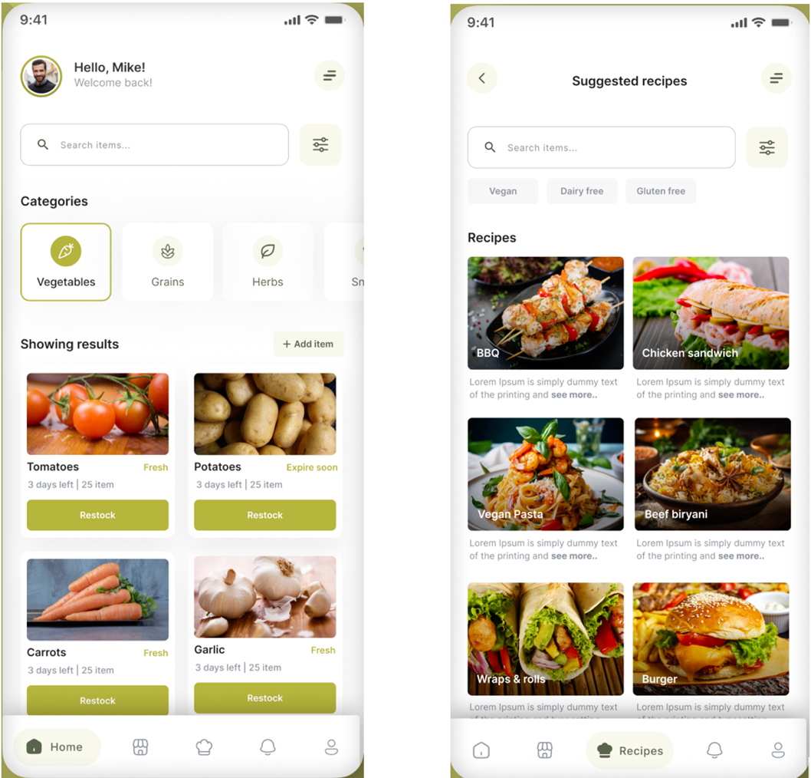

Figure 3: Sample screens from the Santry mobile application prototype, showcasing the pantry overview (left) and the recipe suggestion interface (right), designed for intuitive navigation and personalized food management.

The figure above showcases selected screens from the final version of the prototype. These visuals illustrate the user journey from the home screen to feature-specific pages such as inventory tracking and recipe suggestions. The consistency in layout and colour palette contributes to a cohesive and welcoming user experience, ultimately supporting the application’s goal of promoting sustainable consumption practices.

## 3.2 System Architecture and Component Responsibilities

The architecture of Santry was carefully designed to ensure modularity, scalability, and seamless user experience across platforms. It integrates a cross-platform mobile frontend, a containerized backend hosted in the cloud, a structured database layer, and AI-powered external services. Each component plays a specialized role while collaborating within a distributed architecture that supports asynchronous processing, real-time feedback, and rich feature delivery.

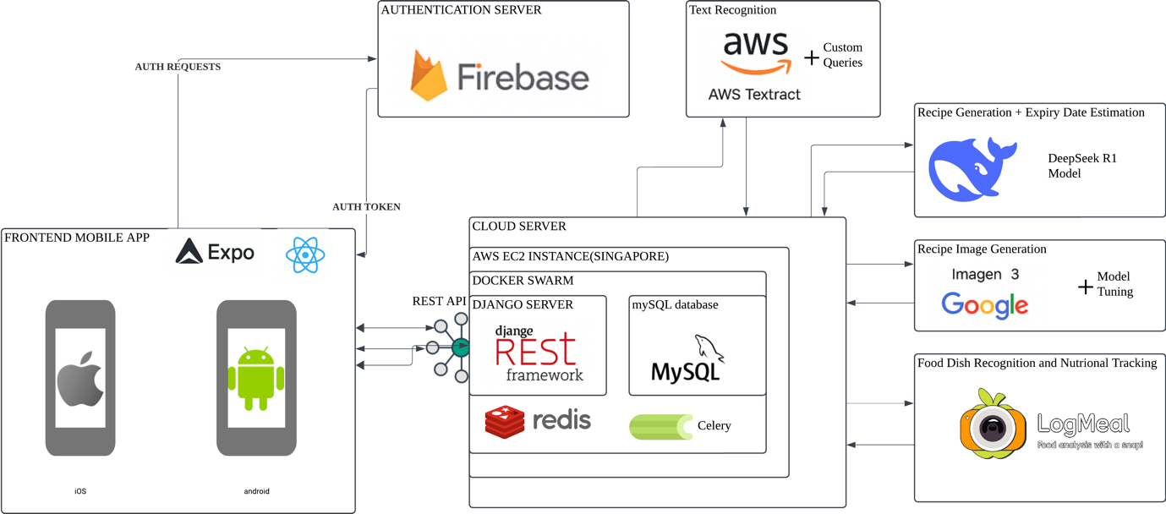

Figure 4: Santry System Architecture Diagram

The figure above illustrates the full-stack system architecture of Santry, highlighting the interaction between frontend, backend, AI services, and storage infrastructure.

### 3.2.1 Mobile Front-end Technologies

The Santry application is built using **React Native**, which enables cross-platform development for both iOS and Android using a shared codebase. This framework was chosen due to its performance efficiency and support for native UI rendering, ensuring a responsive experience across devices [30]. The frontend is bootstrapped using **Expo**, which simplifies the development lifecycle and accelerates testing and deployment [31].

The mobile application is responsible for user interaction and initiates key actions such as:

* Uploading receipts for OCR processing,
* Submitting voice transcripts,
* Fetching recipe recommendations,
* Displaying inventory and expiry reminders.

These tasks are supported by a clean and intuitive interface optimized for minimal interaction depth and broad age-group usability.

### 3.2.2 Authentication Server

User authentication is managed through **Firebase Authentication**, a cloud-hosted solution that provides secure, token-based access control [32]. Firebase was selected for its rapid integration, support for third-party login providers (Google, Facebook), and seamless compatibility with mobile SDKs. Upon login, Firebase issues **JWT tokens**, which are used to authenticate each REST API call made by the client to the backend server.

### 3.2.3 Backend Server and Container Management

At the core of Santry’s backend is a **Django REST Framework (DRF)** application, hosted on an **AWS EC2 instance** in the Singapore region. The backend was fully containerized using **Docker Compose** to manage dependencies and isolate services within a scalable, modular environment [33]. While Docker Swarm was considered for orchestration, Docker Compose was prioritized during the initial development stage due to its simplicity and rapid deployment capabilities.

The Django server performs key operations:

* Routing authenticated requests from the frontend,
* Validating user inputs,
* Communicating with the MySQL database,
* Triggering Celery background jobs for time-consuming tasks.

All backend components are deployed within containers, including Celery workers, Redis, and MySQL, which communicate over an internal bridge network.

### 3.2.4 Database Layer

The application uses **MySQL** as its relational database for storing persistent data, including:

* User profiles and preferences,
* Inventory items,
* Generated recipes,
* Nutritional information.

MySQL was selected due to its strong performance with structured data, ACID compliance, and widespread industry support [34].

### 3.2.5 Asynchronous Task Processing

Time-intensive processes, such as OCR and recipe generation, are offloaded to **Celery**, a distributed task queue system. Celery uses **Redis** as both a message broker and temporary result store. Upon task submission, Django creates a job and hands it off to Celery, which processes it in the background and stores the result in Redis, accessible via a unique task identification number.

This asynchronous architecture ensures:

* Users are not blocked while tasks are processed,
* Tasks can be retried on failure,
* Real-time progress can be tracked.

Such architecture significantly enhances scalability and user experience for applications with compute-heavy features [35].

### 3.2.6 Cloud File Storage

All uploaded images (e.g., grocery receipts, recipe illustrations) are stored in **Amazon S3**, a highly durable and scalable object storage solution. S3 enables efficient access to files across services and serves as a centralized media repository for both user-uploaded and AI-generated content [36].

### 3.2.7 AI Service Integration

Several external AI services are integrated into the system to enable Santry’s intelligent features:

* **AWS Textract**: Performs OCR on receipts to extract text data such as product names and prices [37].
* **DeepSeek R1 Model**: A large language model used for:
  + Expiry date prediction,
  + Voice transcript parsing,
  + Recipe generation using inventory inputs.
* **Google Imagen 3**: Generates visual representations of recipes using only their titles, improving user engagement with aesthetically relevant imagery [38].
* **LogMeal API**: An AI-based food recognition tool that processes photos of prepared meals and returns estimated nutritional information [39].

These integrations allow Santry to provide value beyond conventional inventory tracking, delivering a personalized and enriched user experience driven by machine learning.

Together, these components form a cohesive ecosystem that powers the Santry application—efficiently linking frontend interactions with cloud-based processing, asynchronous task execution, and intelligent response generation.

## 3.3 Feature Workflow – A Deep Dive

This sub-section presents a detailed examination of the key features within the Santry application, emphasizing how user actions are handled through a combination of frontend interaction, backend orchestration, and AI-powered decision-making. Each feature follows a clearly defined workflow involving asynchronous processing, third-party services, and data persistence to deliver responsive and intelligent functionality.

### 3.3.1 Receipt Scanning Workflow

One of the primary ways users add food items into Santry is by uploading a photo of a grocery receipt. This process is streamlined through an OCR-powered pipeline that automatically extracts product names, quantities, and pricing information from the image.

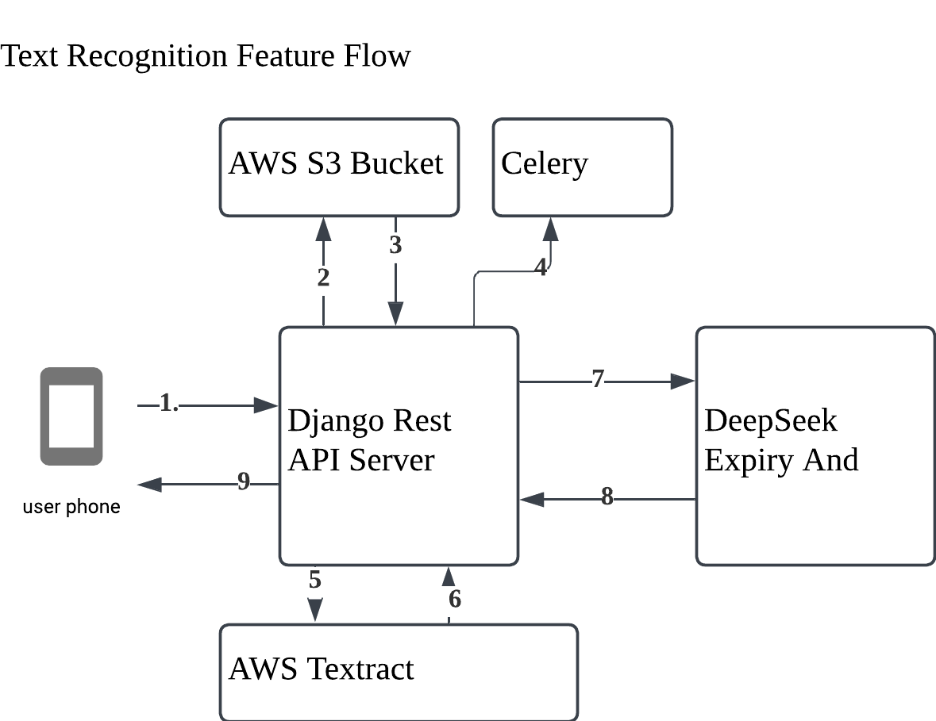

Figure 5: Workflow diagram for the text recognition feature in Santry, illustrating the end-to-end process from image upload to expiry estimation using AWS Textract and DeepSeek.

The workflow begins when the user captures or uploads a receipt image within the mobile app. The image is sent to the backend via a REST API call. The Django server stores the image in **Amazon S3** and immediately dispatches an asynchronous **Celery task** for OCR processing. This task invokes **AWS Textract**, which extracts raw text from the image [40].

The extracted text is then parsed to identify product-related information. Items with high-confidence scores (≥90%) are sent to the **DeepSeek R1 model**, which determines storage requirements (e.g., room temperature, refrigeration), estimates expiry dates, and provides preservation tips. The final structured result is stored temporarily in **Redis**, accessible to the frontend via a unique identification number. This pipeline allows users to populate their inventory with minimal manual input.

### 3.3.2 Voice Input and Expiry Prediction

In addition to receipts, Santry supports **natural voice input**, enabling users to speak their grocery list directly into the app. This feature improves accessibility and provides an efficient alternative to typing.

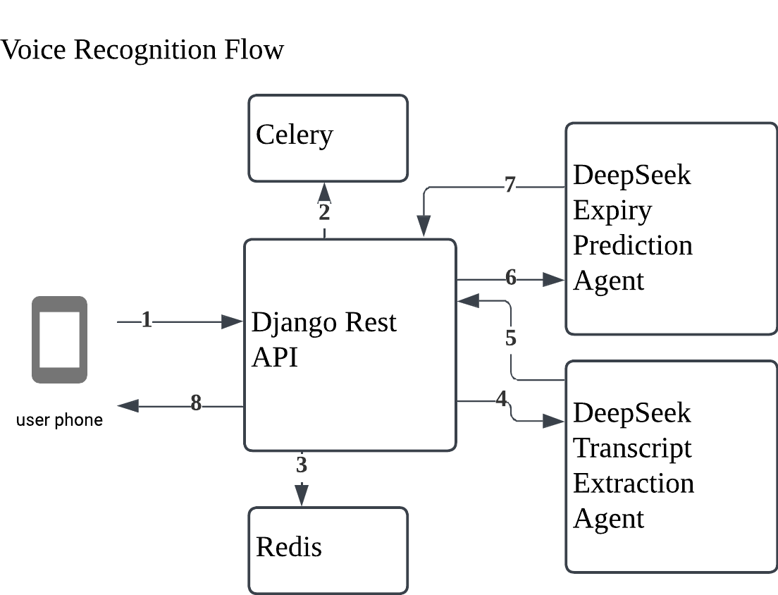

Figure 6: Workflow diagram for voice recognition in Santry, outlining the backend processing steps for converting natural language grocery input into structured inventory entries using DeepSeek.

Once the user submits a voice transcript, the text is sent to the backend for semantic parsing. The **DeepSeek model** processes the input to identify food items, quantities, modifiers (e.g., “fresh,” “frozen”), and other relevant attributes. Each recognized item is run through the same expiry estimation pipeline used in receipt scanning, leveraging the DeepSeek assistant’s contextual reasoning capabilities.

The backend formats the result, including estimated shelf life and storage instructions, and stores it in **Redis** for fast retrieval. By offloading computation to asynchronous tasks, the app ensures real-time responsiveness even for complex voice inputs.

### 3.3.3 Recipe Suggestion Workflow

Recipe generation in Santry is tightly coupled with the user's current inventory. The system automatically creates recipes based on available ingredients, helping users plan meals that reduce food waste.

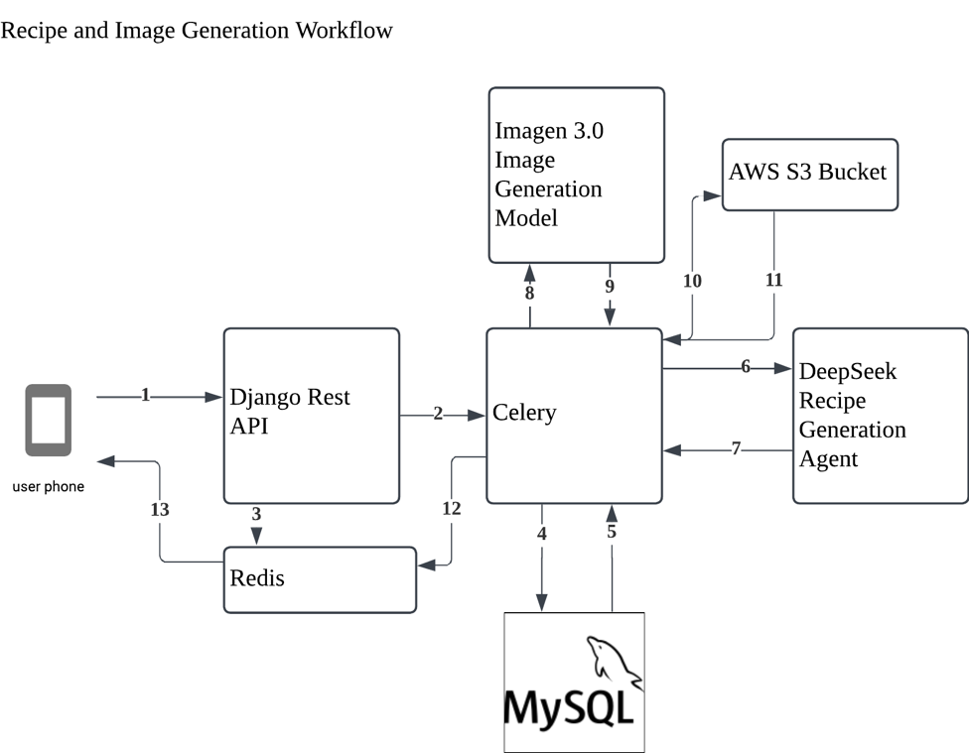

Figure 7: Workflow diagram for recipe and image generation in Santry, demonstrating how inventory triggers automated meal planning and AI-driven visual content creation.

Whenever inventory changes—such as after adding new items—a Celery task is triggered. This task queries the MySQL database for the updated inventory list and sends it to the **DeepSeek LLM**, which generates up to 15 custom recipes. Each recipe includes a title, list of ingredients (sourced from the user’s pantry), cooking instructions, and preparation time.

After generation, the recipes are saved to the database and associated with the user’s profile. An additional background task calls **Google’s Imagen 3 model**, which generates an image for each recipe using its title as a prompt [41]. These images are uploaded to AWS **S3** and linked to the corresponding recipe record. The frontend retrieves and displays both content and imagery, offering a visually rich and practical cooking guide.

### 3.3.4 Dish Scanning and Nutritional Breakdown

To further support dietary awareness, Santry allows users to photograph prepared meals and receive nutritional insights in return.

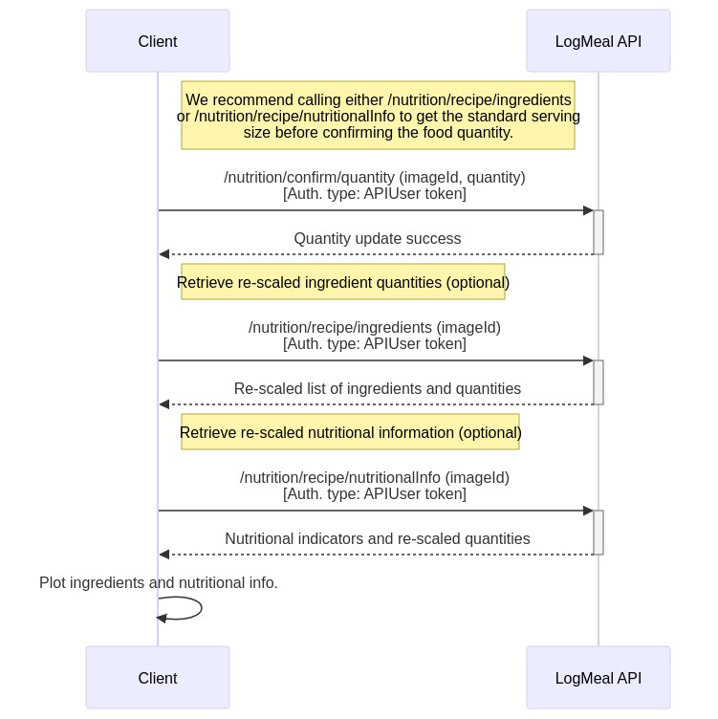

Figure 8: Interaction flow between the Santry client and LogMeal API for food dish recognition and nutritional analysis based on AI-processed images[39].

When a dish image is submitted, it is sent via API to the backend, which forwards it to the **LogMeal API**, a deep learning model trained for multi-class food recognition [42]. The model returns the likely food category and nutritional breakdown, including calories, macronutrients, and selected vitamins.

This data is displayed to the user and optionally saved to their nutritional history. By integrating visual analysis of meals, this feature adds a health-conscious dimension to Santry, reinforcing informed consumption habits.

## 3.4 API-First Design and Data Handling

Santry's development embraced an **API-first design philosophy**, wherein all frontend functionalities is built around well-defined, versioned, and reusable REST APIs. This approach enabled modularity, parallel development of client and server layers, and consistent behaviour across all user interactions. By treating APIs as the contract between the frontend and backend, the architecture ensured that new features could be integrated or tested independently, reducing regression risks and improving scalability [43].

### 3.4.1 RESTful Service Design

The backend of Santry is built using the **Django REST Framework (DRF)**, which provides serializers, view sets, and routers for exposing structured data via HTTP endpoints. Each core feature—such as inventory updates, receipt processing, recipe generation, and nutritional feedback—is implemented as a distinct API route, using clear, resource-oriented URL structures. For example:

* POST /inventory/upload-receipt/
* POST /voice-input/
* GET /recipes/{user_id}/
* GET /nutrition/{item_id}/

This uniform interface design simplifies frontend development, enhances API discoverability, and aligns with REST best practices [44].

Each request is authenticated using **Firebase-issued JWT tokens**, which are validated on the backend to enforce access control. Error responses follow a standardized schema, enabling the frontend to handle failures gracefully and provide actionable feedback to users.

### 3.4.2 Structured Data Persistence

All persistent data in Santry is stored in a **MySQL** relational database. The schema is carefully designed to maintain normalized data integrity while supporting fast relational queries.

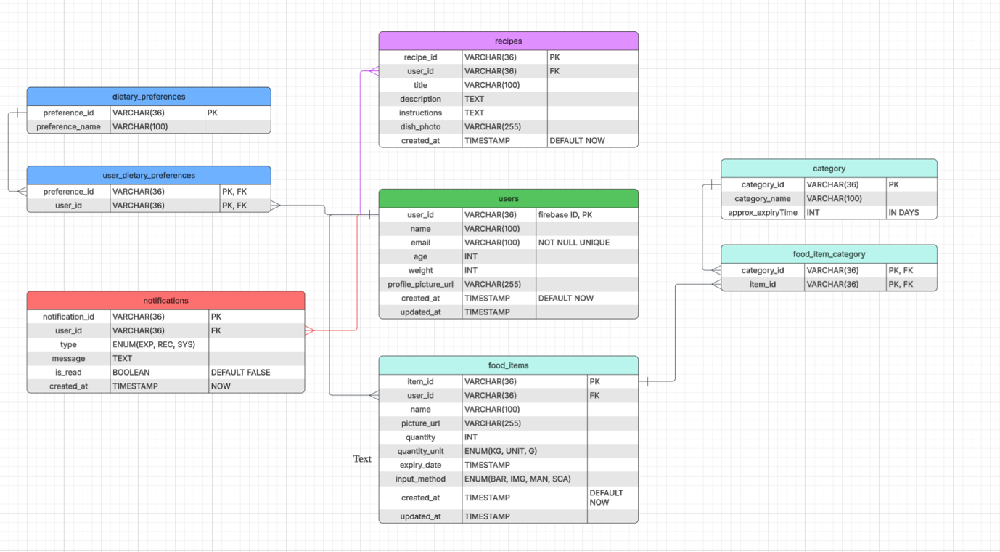

Figure 9: Santry database schema showing core entities and relationships for managing users, food items, preferences, categories, recipes, and notifications.

The diagram above visualizes the structured relational schema implemented in Santry’s MySQL database. At the center is the **users** table, which stores unique Firebase-authenticated profiles alongside demographic attributes like age and weight. Each user is linked to multiple **food_items**, which capture details such as item name, quantity, expiry date, and input method (e.g., barcode, manual entry, receipt scanning).

The **category** and **food_item_category** tables establish many-to-many relationships between items and their associated expiry heuristics, enabling dynamic classification and prediction workflows. The **recipes** table stores AI-generated recipes tied to users, complete with instructions and dish imagery, while the **notifications** table tracks real-time alerts for events such as upcoming expiries or suggested recipes.

Additionally, the schema supports dietary personalization through the **dietary_preferences** and **user_dietary_preferences** tables, ensuring that recipe suggestions align with individual user needs. This normalized design ensures efficient query performance and seamless integration of personalized AI outputs into the user experience.

## Frontend Mobile Application Implementation

The frontend of Santry is developed using **React Native**, a framework that allows the building of high-performance mobile applications for both **iOS and Android** using a shared JavaScript codebase. This approach significantly accelerated development and ensured consistent behaviour across platforms. The frontend is structured to support modular feature development, optimized rendering performance, and responsive layouts that accommodate a wide user demographic.

The project leveraged **Expo**, an open-source platform built around React Native, to streamline development workflows such as hot reloading, asset bundling, device previews, and OTA (over-the-air) updates [47]. This allowed for rapid iteration during the prototyping phase and simplified deployment to real devices during testing.

### 3.5.1 UI/UX Principles

User interface design is informed by the principle of **minimal interaction depth**, ensuring that all major actions—such as adding food items, viewing expiry dates, or accessing recipe suggestions—could be completed within **four to five taps**. A clean and intuitive navigation structure is established using **React Navigation**, with a bottom tab bar providing quick access to key screens: Inventory, Recipes, Input, and Profile.

The visual design employed **green and earth-toned color palettes**, reflecting the sustainable mission of the app while also providing a calming and accessible aesthetic. UI components are constructed using reusable functional elements styled with **TailwindCSS (via NativeWind)** to maintain visual consistency while supporting component-level customization.

Text elements are sized and spaced to ensure **readability across age groups (15–60),** with adequate padding and touch targets to support both younger and older users. Iconography is selected from open-source libraries (e.g., Lucide, Feather) and used alongside text labels to reinforce clarity.

### 3.5.2 State Management and Data Binding

Application state is managed using a combination of **React Context** and **custom hooks** for lightweight and scalable state control. For more complex features—such as task polling or dynamic inventory updates—local state is synchronized with remote API data using useEffect() and fetch() with debouncing logic to prevent redundant calls.

Data retrieved from the backend is cached selectively in memory to support instant UI rendering and reduce perceived latency. Feature-specific components listen for state changes and reactively update UI elements such as countdown timers, inventory freshness labels, or recipe availability indicators.

### 3.5.3 Form Handling and User Input

User input flows (e.g., item addition, manual editing, voice transcript review) are managed using controlled components and validated using custom logic before submission to the backend. Dropdowns, modals, and pickers are employed contextually to limit user error and encourage meaningful interactions.

Where applicable, feedback elements such as **snackbars, loading indicators**, and **confirmation prompts** are displayed to enhance the sense of responsiveness and user control.

Through its thoughtful implementation, the frontend of Santry acts as a responsive, inclusive, and aesthetically cohesive interface that brings the application’s intelligent backend features to life—delivering a seamless experience aligned with the app’s mission of reducing household food waste.

## Cloud Architecture and Deployment

Santry is architected for high availability, modularity, and ease of scaling through a cloud-native deployment strategy. The infrastructure is built using containerized microservices hosted on **Amazon Web Services (AWS)** and orchestrated using **Docker Swarm** for development and deployment. The architecture ensures that compute, storage, and task handling components are loosely coupled yet efficiently integrated, supporting asynchronous workflows and real-time responsiveness.

### 3.6.1 Cloud Hosting and Scalable Deployment Stack

The backend services are deployed on a dedicated **EC2 instance** in the **ap-southeast-1 (Singapore)** AWS region, chosen for its proximity to the target user base and low-latency networking . All core services—including the Django REST API server, Celery workers, Redis, and MySQL—are packaged as Docker containers and launched as a cohesive stack using **Docker Compose**.

This setup allows for reproducible builds, simplified version control, and rapid redeployment in case of service updates or configuration changes. Although **Docker Swarm** was considered for production orchestration, Docker Compose was favoured for its simplicity during the prototype phase.

### 3.6.2 Image Storage System

**Amazon S3** serves as the object store for all assets, including:

* Uploaded receipt scans,
* Dish photos from users,
* AI-generated recipe illustrations.

S3’s scalability and fault tolerance ensure that large media files are handled efficiently and securely, without bloating server storage. Files are referenced by URL within the MySQL database, allowing seamless frontend retrieval.

### 3.6.3 Task Management and Load Distribution

To ensure responsiveness under heavy computational load, all resource-intensive operations—such as text recognition, recipe generation, and image synthesis—are offloaded to **Celery workers**. These background tasks are queued and managed asynchronously, with **Redis** acting as both the broker and result store.

This architecture allows the application to scale horizontally by simply adding more Celery worker instances. Failed tasks can be retried automatically, and job tracking is facilitated through unique task identification numbers retrievable by the client interface.

### 3.6.4 Data Storage and Backup Systems

The **MySQL database** is hosted in a Docker volume within the EC2 instance, protected by encrypted snapshots and scheduled backup routines. The schema is normalized and indexed for query performance, and sensitive operations are logged for traceability.

To enhance data resilience, scheduled database dumps are stored in S3, and access to the database is restricted to the internal network. User authentication is handled externally via **Firebase**, ensuring that the application server is decoupled from sensitive identity data [46].

Through a carefully layered cloud deployment strategy, Santry achieves operational reliability and flexibility—laying the foundation for future feature expansion, geographical scaling, and long-term maintainability.

# 4. Project outcome and results

This section evaluates the outcomes of the Santry application based on its core features and technical components. It presents a detailed analysis of what is successfully implemented, the extent to which each feature met its intended objectives, and the limitations encountered during development. By examining each major functionality individually, this section offers a comprehensive overview of the system’s performance, usability, and overall effectiveness in addressing household food waste.

## 4.1.Receipt Scanning Feature

### **Outcome**

The receipt scanning feature of Santry successfully transforms the traditionally tedious process of inputting grocery items into an automated, efficient, and user-friendly experience. By leveraging AWS Textract for Optical Character Recognition (OCR), the app can extract individual product entries from printed receipts and relay this data to a background processing pipeline. The feature is tightly integrated into the user interface with real-time visual feedback, making it one of the core enablers of Santry's smart inventory system.

Once the user captures a receipt through the in-app camera interface, a processing screen engages them with a visual animation and food preservation tips, keeping them occupied while the OCR and AI tasks complete. Within approximately 10 to 15 seconds, the system returns a detailed, editable list of detected items, each tagged with an estimated expiry date and storage recommendation.

 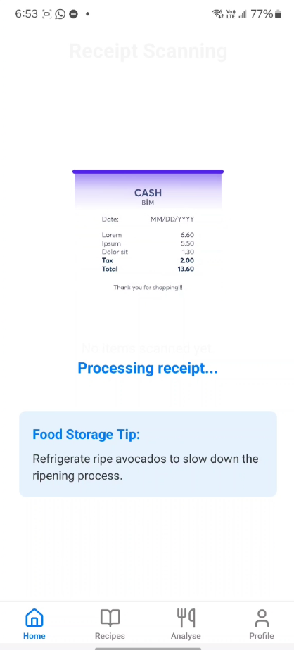 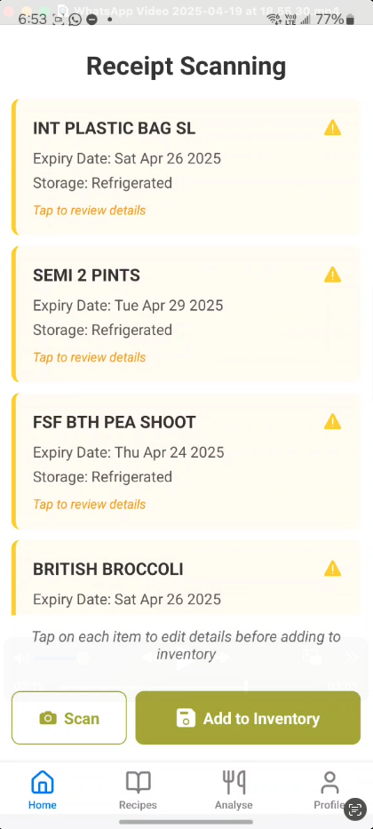

Figure 10: Screenshots illustrating the full receipt scanning workflow in Santry — from receipt capture to expiry prediction and inventory preparation.

The experience is designed to be seamless: after scanning, users can review each item, correct or delete misidentified entries, and add items to their inventory with a single tap. Items like "BRITISH BROCCOLI" and "SEMI 2 PINTS" are correctly identified and enriched with expiry predictions based on semantic classification by the DeepSeek AI model. This end-to-end pipeline significantly lowers the barrier to maintaining a digital food inventory and aligns strongly with the app’s goal of minimizing household food waste.

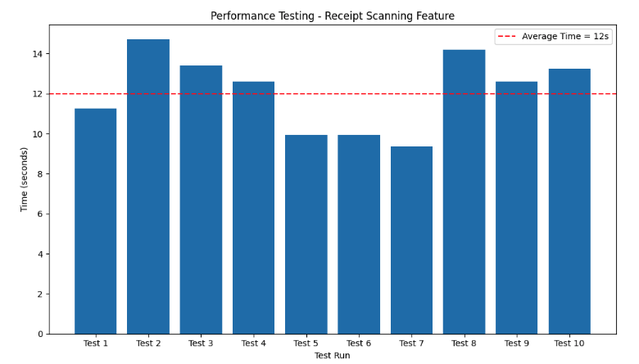

Figure 11: Performance testing chart for the receipt scanning feature, showing 10 runs with an average response time of 12 seconds.

From a performance standpoint, the feature demonstrates consistent response times. Based on internal testing across 10 runs, the average processing time stabilizes around 12 seconds — with a few peaks and troughs observed depending on receipt complexity and server load.

### **Limitations**

Despite its strengths, the receipt scanning feature presents several limitations that require further refinement. One prominent issue is **over-detection** — the OCR system captures all items in a grocery list, including non-food items such as "PLASTIC BAG"

Another challenge arises from **non-standard or ambiguous product names**. Items listed with shorthand or branded formats — such as "FREERNG 12" for eggs — can cause the expiry prediction model to fail or return inaccurate results. The DeepSeek model, while robust for common descriptors, struggles with vague or marketing-heavy product codes, which are frequent in real-world receipts.

These limitations currently require the user to verify or correct the automatically detected entries, adding friction to an otherwise smooth flow. Although the interface facilitates easy editing, fully eliminating the need for user intervention remains an ongoing development goal.

Nonetheless, the feature’s design succeeds in guiding the user through an efficient and largely automated process, balancing intelligence with transparency. Future iterations may address these constraints through enhanced entity recognition, machine learning–based filtering, and training on localized retail data.

## 4.2. Recipe and Image Generation Feature

### **Outcome**

The recipe and image generation feature is a standout achievement of the Santry application, delivering immediate, personalized meal suggestions based entirely on the user’s live inventory. Whenever the user adds or removes food items from their pantry, the backend automatically triggers an asynchronous Celery task that regenerates a list of recipes aligned with the updated ingredient list.

Each generated recipe includes a title, list of required ingredients, step-by-step instructions, and an estimated preparation time. The results are then sent to the frontend, where users can browse through a curated set of up to 15 dishes, all crafted from what they already have at home. This feature significantly supports Santry’s core mission of helping users **consume what they already own**, minimizing unnecessary food waste.

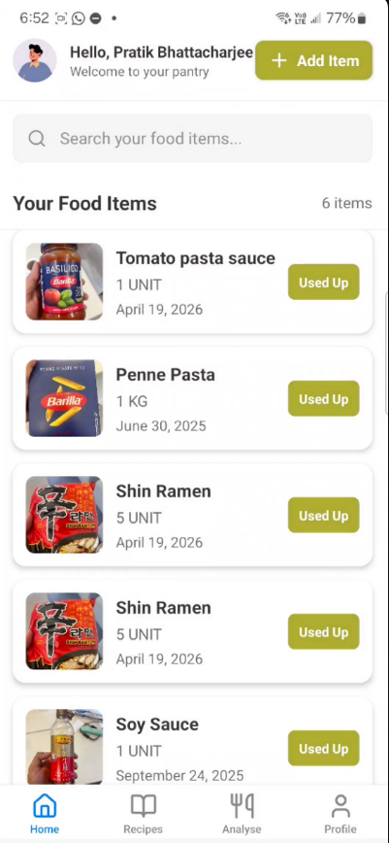 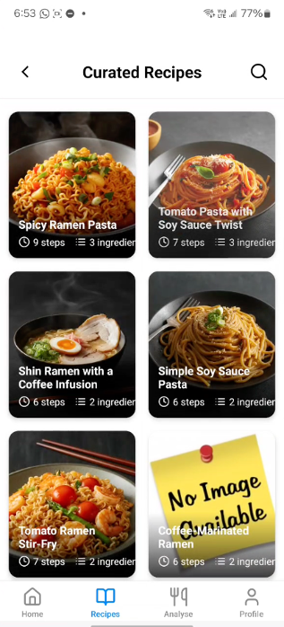

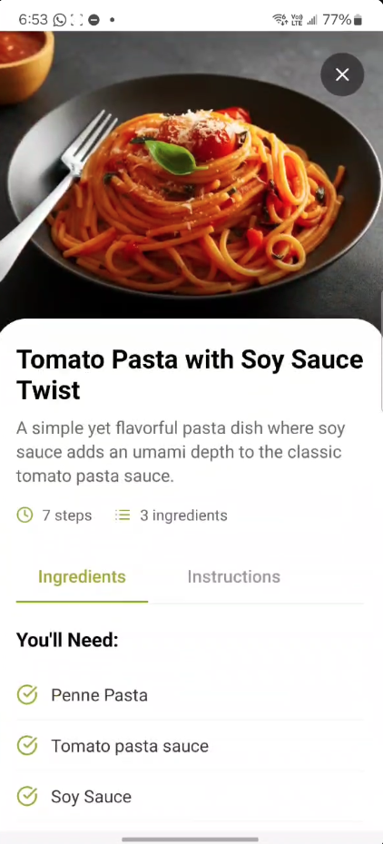 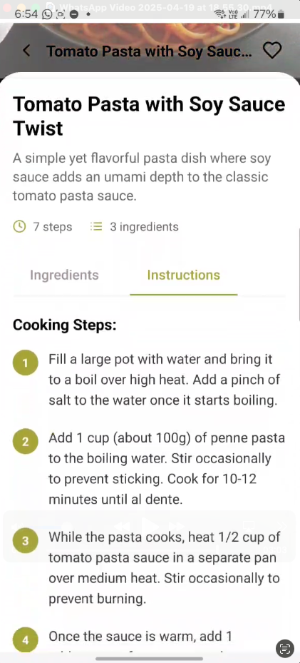

Figure 12: Screenshots demonstrating the curated recipe list, a detailed recipe view, and full cooking instructions—all generated dynamically based on inventory.

What enhances the experience further is the use of **Google Imagen 3**, a powerful text-to-image generation model. Once recipes are created by the DeepSeek language model, their titles are passed to Imagen 3, which returns realistic and engaging images of each dish. These AI-generated visuals give users a more appetizing and immersive browsing experience, setting Santry apart from generic recipe apps that lack visual depth.

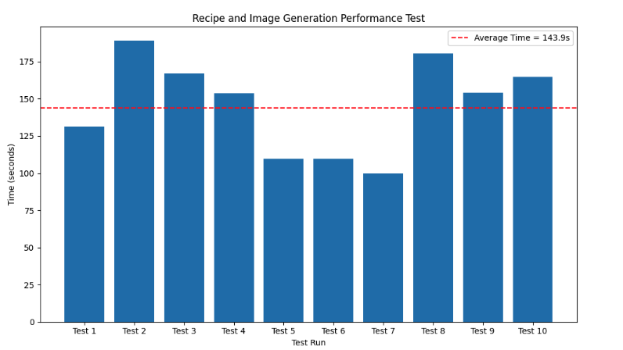

Figure 13: Performance benchmarking for recipe and image generation across 10 runs, showing an average total response time of ~144 seconds.

The image generation process occurs in parallel to recipe creation, and both are handled via Celery to avoid blocking the main application thread. Users receive a complete set of content—text and images—within approximately 2.5 minutes from the moment an inventory change occurs. The result is a seamless, hands-off experience where users are inspired to cook without needing to think too hard about what’s available.

### **Limitations**

While the system functions effectively under typical conditions, two notable limitations exist in its current implementation. First, **image generation reliability** is not absolute. The Google Imagen 3 API occasionally fails to return images, with an estimated **2–3% failure rate**. In such cases, the app displays a placeholder or generic thumbnail, which slightly detracts from the immersive experience. This issue, though minor in frequency, introduces inconsistency in presentation and may affect user trust if encountered repeatedly.

Second, although the DeepSeek model generates recipes with impressive coherence and structure, approximately **10% of the results contain unconventional or unusual meal ideas**. These may include strange ingredient combinations or culturally unfamiliar dishes. While novelty can be valuable, further prompt tuning and domain-specific fine-tuning would help make the generated recipes more contextually appropriate and aligned with local user expectations.

Additionally, the time taken to process a full batch of recipes and images—averaging around 2.5 minutes—may feel long to some users, especially in lower bandwidth environments. While the asynchronous approach prevents the UI from freezing, perceived latency could still be improved through optimization strategies or a progressive content-loading approach.

Overall, the feature represents a **highly innovative use of generative AI** within a practical mobile environment, and despite its limitations, it offers a compelling solution to meal planning with available food items.

## 4.3. Dish Scanning and Nutritional Feedback Feature

### Outcome

Santry’s dish scanning feature allows users to take a photo of any prepared meal and receive an instant breakdown of ingredients and nutritional values. This functionality is powered by the LogMeal API, a food recognition platform trained on thousands of meal types. The process begins with the user uploading or capturing a photo of their dish via the "Analyse" section of the app, after which a background task is triggered to identify food items and estimate quantities, calories, macronutrients, and other dietary information.

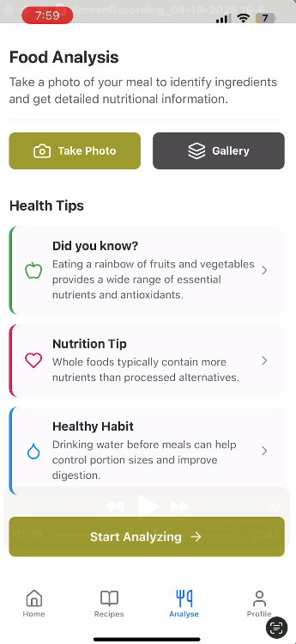 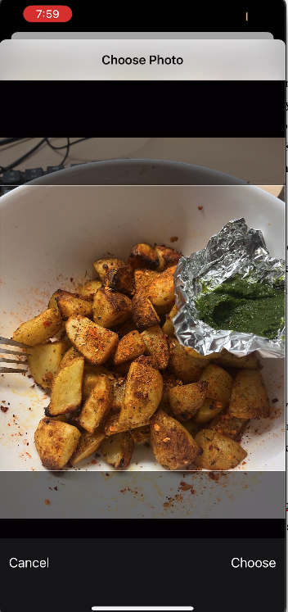 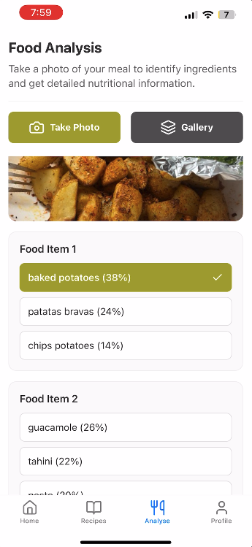

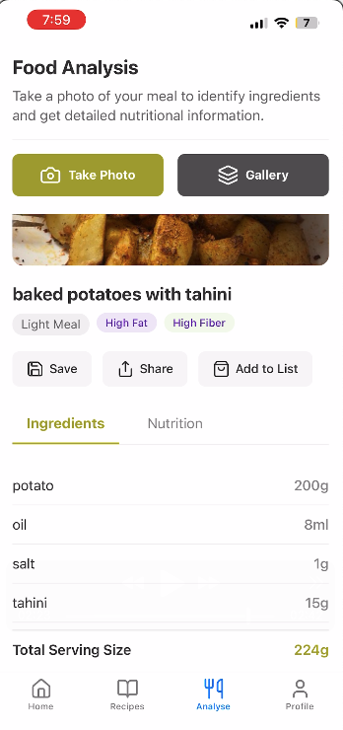 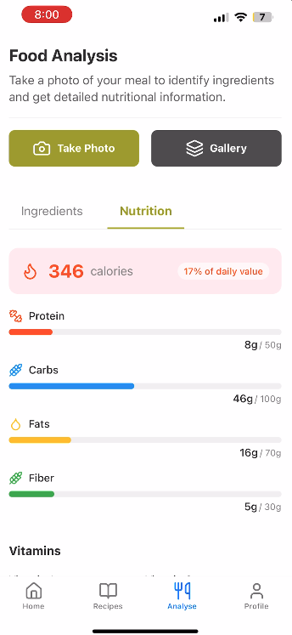

Figure 14: Screenshots illustrating the complete workflow of the dish scanning and nutritional analysis feature, from image input to detailed nutrition breakdown.

One of the strengths of this feature is the user-centric confirmation flow. After initial detection, users are allowed to review and select from a ranked list of predicted items (e.g., “baked potatoes,” “patatas bravas,” “chips potatoes”), thereby increasing confidence and accuracy in the final analysis. Once confirmed, the system displays detailed ingredient breakdowns by weight, serving size, and calorie distribution, accompanied by colorful UI indicators for fats, proteins, fiber, and vitamins.

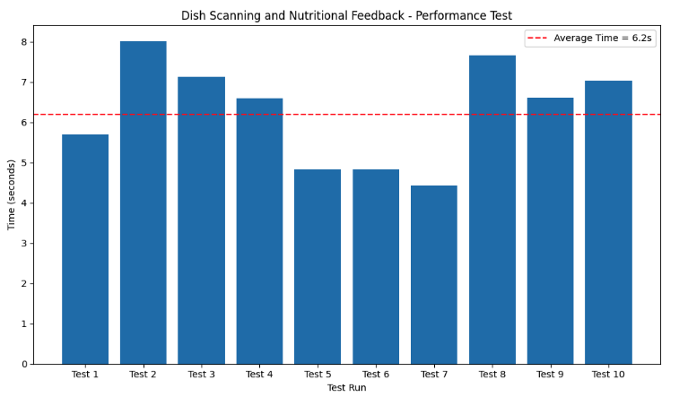

Figure 15: Dish scanning and nutritional analysis performance across 10 test runs, with an average processing time of 6.2 seconds.

The speed of execution is another highlight. In performance testing, the feature consistently delivered results in under 7 seconds across most test cases. Given that image recognition and nutritional data fetching are often resource-intensive tasks, this level of responsiveness demonstrates strong backend performance and API efficiency.

This feature reinforces Santry’s role not just in food inventory management but also in **nutritional mindfulness**. It empowers users to make informed eating choices by analyzing what they are about to consume, making the app a more holistic solution for health-conscious households.

### Limitations

Despite its effectiveness, the feature currently faces limitations rooted in the capabilities of the external LogMeal service.Firstly, **cultural bias in recognition accuracy** is evident. While Western or globally common dishes are typically recognized with high accuracy, **many traditional Asian that are not available in western countries are misclassified**. This is due to the LogMeal API's training set, which includes approximately 1,300 meal types but with limited regional diversity. Consequently, users consuming highly localized meals may not receive accurate or useful feedback.

Another constraint is the **maximum of six detected items per dish**, a restriction imposed by the API. For simple or moderately complex dishes, this limit is sufficient. However, elaborate meals with numerous ingredients (e.g., stews, mixed platters, or hot pots) are likely to be underrepresented in analysis. Although rare, this limitation can compromise accuracy for more complex meals.

Additionally, **image quality significantly affects output**. Poor lighting, unflattering angles, or cluttered plates can lead to incorrect predictions. While this issue is common to most vision-based models, it could be mitigated through better in-app guidance. Santry plans to introduce photo-taking instructions or templates in future releases to help users capture more optimal input images.

Despite these drawbacks, the feature has proven to be a **fast, intuitive, and highly engaging addition** to the Santry ecosystem, promoting dietary awareness and enhancing user interaction with AI-powered food tech.

## 4.4 Overall Project Outcome

### **4.4.1 User Interface and Experience**

The Santry application delivers a user interface that is both modern and intuitive, successfully reflecting the design vision established during the prototype phase. Multiple UI iterations ensured that all user interactions—whether scanning, browsing, or confirming items—are streamlined and accessible. A major strength of the app lies in its cohesiveness, where all features are unified in a clean, consistent experience. The interface is designed to serve a wide age range and is optimized for both **Android and iOS**, as demonstrated by the platform-agnostic screenshots featured throughout this report.

### **4.4.2 Backend System and Cloud Deployment**

The backend and cloud infrastructure proved highly reliable during testing. The system, containerized and deployed via Docker on AWS EC2, successfully managed concurrent asynchronous tasks and API communications without failure. While some latency was observed in performance tests—particularly in AI-driven workflows—this is primarily attributed to the cloud server being located outside Hong Kong, where testing was conducted. With increased funding, this can be mitigated by deploying servers to a **regionally optimized availability zone**

Despite these constraints, the system has been architected with **scalability in mind**, making it easy to extend across regions or adapt to larger user loads in future development phases.

### **4.4.3 Completion and Impact**

Santry stands as a complete and functional solution to the problem of household food wastage. The integration of diverse features—from inventory scanning and expiry prediction to recipe generation and nutritional feedback—demonstrates a high level of **system integration and technical execution**. The modular design supports further innovation, and limitations observed during development are primarily infrastructure-related rather than architectural. The project lays a strong foundation for a production-ready product and clearly illustrates its potential to contribute to sustainable living in urban environments.

# 5. Project Schedule

This section elaborates on the schedule followed in order to complete this project.

|  |  |  |
| --- | --- | --- |
| Stage | Project Stages | Timeline |
| 1 | Market Research and Prototype Development | 1st August 2024 – 15th November 2024 |
| 2 | System Design Research and Development | 18th September 2024- 30th November 2024 |
| 3 | Develop Django REST framework backend service development with MySQL DB sever and API Testing using Postman | 25th December 2024 – 20th January 2025 |
| 4 | Cloud Architecture Setup and CICD pipeline Setup with GitHub and AWS. | 29th January 2025 – 16th February 2025 |
| 5 | React Native front-end mobile application development to match prototype | 12th January 2025 – 28th March 2025 |
| 6 | AI Services Integration with Backend and AI model tuning | 14th February 2025 – 24th February 2025 |
| 7 | Backend integration of the mobile application and Integration Testing | 1st March 2025 – 10th April 2025 |
| 8 | Bug Fixes and System Testing | 3rd April 2025 – 20th April 2025 |
| 9 | Final Code Documentation and Code submission. | 20th April 2025- 25th April 2025 |

Table 1: Project Schedule undertaken for the completion of this project

# 6. Future Works

While Santry has made significant progress in addressing the problem of household food waste through a feature-rich, AI-assisted mobile application, the project remains in an early-phase prototype stage. To transform this system into a fully deployable and widely impactful product, several avenues for future enhancement have been identified. These directions not only build upon the current architecture but also aim to improve usability, cultural relevance, scalability, and independence from third-party dependencies.

### **6.1 Integration with Retail and IoT Ecosystems**

One of the most promising directions for expanding Santry’s impact lies in its integration with **retail systems and Internet of Things (IoT)** devices. Currently, the application allows users to manually input food items or upload grocery receipts for OCR-based inventory addition. However, the process can be further streamlined through **direct integration with supermarket APIs**. Many modern grocery stores offer digital receipts or maintain purchase history through loyalty accounts. By connecting Santry with these services—through secure APIs—the application could **automatically import grocery purchases**, populate the inventory in real time, and assign expiry predictions with minimal user intervention. This would reduce the need for manual effort or image-based input entirely, creating a seamless experience that enhances both accuracy and convenience.

Additionally, the rise of **smart kitchen appliances and sensors** opens up new possibilities for household food tracking. Future iterations of Santry could integrate with **barcode scanners, RFID-enabled pantry systems,** or **smart refrigerators** to provide real-time inventory updates. For example, a barcode scan at the point of pantry entry could trigger item registration, while RFID tags could allow the app to continuously monitor what’s in stock. These integrations would transform Santry from a manual tool into an **automated smart pantry system**, elevating its practicality and aligning with broader smart home trends.

### **6.2 Localized Language Support for Hong Kong Users**

As Santry is developed specifically with the Hong Kong context in mind, **supporting local languages such as Cantonese and Traditional Chinese** is crucial for accessibility and adoption. Currently, the interface and processing pipelines are primarily English-based. In a future release, all user-facing text, navigation labels, instructions, and feedback should be **localized to Cantonese and Mandarin**, using appropriate translation and UI adaptation for character-heavy languages.

More importantly, the **voice input and OCR systems must also accommodate multilingual recognition**. This would involve training or fine-tuning language models to support Cantonese grocery item names, colloquialisms, and shopping patterns. Additionally, enabling the OCR system to process Traditional Chinese characters on receipts would greatly improve the accuracy and usability of the receipt scanning feature in local contexts. This enhancement would make Santry truly accessible and functional for the diverse population of Hong Kong, including elderly users who may not be proficient in English.

### **6.3 Enhanced Authentication and Onboarding Options**

To improve usability and broaden adoption, future versions of Santry should support **multiple authentication methods** beyond email and password. Many users prefer the convenience of signing in through **federated identity providers** such as **Google, Facebook, or Apple ID**. These providers not only simplify the signup process but also improve security through standardized OAuth protocols.

By integrating with Firebase Authentication’s extended offerings, Santry could allow new users to sign up with a single tap, reducing friction during onboarding. This would be particularly useful for younger users or those accustomed to using social sign-ins across other apps. Additionally, leveraging social login can assist in gathering verified user data (with consent) for personalized feature recommendations and analytics.

Moreover, multi-device synchronization and passwordless login features such as **Magic Links or biometric authentication** (Face ID, fingerprint scanning) could also be introduced to align with modern UX expectations and further enhance data security.

### **6.4 Development of a Custom Dish Recognition Model for Hong Kong**

Currently, Santry relies on **LogMeal**, a third-party API for food image recognition and nutritional analysis. While this service has proven effective during the prototype phase, it presents several limitations. Most notably, the model is **trained on general or Western-centric food datasets**, leading to reduced accuracy when recognizing Hong Kong–specific dishes, ingredients, or preparation styles. This limits the cultural relevance and utility of the nutritional scanning feature.

A key area of future work is to **build a proprietary dish recognition model** specifically trained on datasets curated from **local user submissions and open-source Hong Kong food databases**. As users upload photos of their meals, this growing dataset can be anonymized and used to fine-tune a custom **Convolutional Neural Network (CNN)** or vision transformer model optimized for regional cuisine.

The development of this internal model would offer several benefits:

* **Improved accuracy and recall** for Chinese and Cantonese dishes.
* **Reduced dependency** on external services, lowering cost and latency.
* **Greater control** over model updates, tuning, and ethical considerations.
* Ability to incorporate **contextual features** such as portion size, time of day, or dietary preferences.

This initiative could be implemented using platforms like **TensorFlow, PyTorch, or Google AutoML Vision**, and would form the basis for a truly localized and scalable smart food recognition engine.

# 7. Conclusion

Santry is conceived as a smart, user-friendly solution to one of the most overlooked yet impactful challenges in modern urban living—household food waste. Through this project, a fully functional, AI-assisted mobile application was developed, combining practical features like grocery receipt scanning, expiry tracking, and inventory-based recipe generation into a seamless and accessible user experience.

The project’s success lies in its ability to integrate advanced technologies—such as OCR, natural language processing, image generation, and nutritional analysis—into a cohesive system supported by a scalable cloud-based architecture. The application’s design-first approach and iterative prototyping ensured a clean, intuitive interface, validated through continuous refinement. Each component, from voice recognition to asynchronous task handling via Celery, was chosen and implemented to deliver reliable performance while maintaining extensibility for future growth.

More importantly, Santry does not simply automate food tracking—it encourages behavioural change. By making it easier for users to track, understand, and utilize their food resources, the app fosters sustainable consumption habits aligned with global goals such as SDG 12.3. Its real-time feedback, visual recipe inspiration, and nutritional insights add value beyond waste reduction, creating an ecosystem that supports mindful living.

While the prototype demonstrates robust functionality, certain limitations—such as regional model accuracy, API response latency, and recognition gaps for local dishes—present important areas for future work. These challenges are known, and the system has been deliberately designed to evolve through modular upgrades, additional training datasets, and deeper integrations with retail and IoT platforms.

In conclusion, this project not only delivers on its technical objectives but also presents a credible, scalable path forward. With continued development, Santry has the potential to contribute meaningfully to environmental sustainability, public health awareness, and the broader movement toward smart home ecosystems.

# References

[1] City Harvest, “Top 10 Food Waste Facts You Need to Know in 2025,” *City Harvest*, 2025. [Online]. Available: <https://cityharvest.org.uk/blog/top-10-food-waste-facts-you-need-to-know-in-2025/>

[2] United Nations Environment Programme, “World Squanders Over 1 Billion Meals a Day – UN Report,” *UNEP*, Mar. 2024. [Online]. Available: <https://www.unep.org/news-and-stories/press-release/world-squanders-over-1-billion-meals-day-un-report>

[3] Food and Agriculture Organization, “The State of Food and Agriculture: Moving Forward on Food Loss and Waste Reduction,” *FAO*, 2023. [Online]. Available: <https://www.fao.org/3/cb9364en/cb9364en.pdf>

[4] WRAP, “Household Food Waste: Economic Impacts and Savings,” *WRAP UK*, 2022. [Online]. Available: <https://wrap.org.uk/resources/report/household-food-waste-economic-impact>

[5] Feeding Hong Kong, “Food Wasted – Education Hub,” *Feeding HK*, 2024. [Online]. Available: <https://feedinghk.org/education/food-wasted/>

[6] Hong Kong Free Press, “Promote Food Waste Reduction at Source, as Well as Recycling, Hong Kong Green Group Urges Government,” *HKFP*, Jun. 2024. [Online]. Available: <https://hongkongfp.com/2024/06/13/promote-food-waste-reduction-at-source-as-well-as-recycling-hong-kong-green-group-urges-government/>

[7] Food and Agriculture Organization, “Consumer Food Waste,” *FAO*, 2023. [Online]. Available: <https://www.fao.org/flw-in-fish-value-chains/value-chain/consumption/consumer-food-waste/en/>

[8] FoodPrint, “The Problem of Food Waste,” *FoodPrint*, 2023. [Online]. Available: <https://foodprint.org/issues/the-problem-of-food-waste/>

[9] United Nations Environment Programme, “World Squanders Over 1 Billion Meals a Day – UN Report,” *UNEP*, Mar. 2024. [Online]. Available: <https://www.unep.org/news-and-stories/press-release/world-squanders-over-1-billion-meals-day-un-report>

[10] Food and Agriculture Organization, “Consumer Food Waste,” *FAO*, 2023. [Online]. Available: <https://www.fao.org/flw-in-fish-value-chains/value-chain/consumption/consumer-food-waste/en/>

[11] T. Zhang, X. Liu, Y. Wang, and L. Chen, “Consumer food waste behaviors in urban households,” *Scientific Reports*, vol. 15, no. 2, Art. no. 86252, 2025. [Online]. Available: <https://www.nature.com/articles/s41598-025-86252-z>

[12] World Resources Institute, “Reducing Food Loss and Food Waste: Setting a Global Action Agenda,” *WRI*, 2022. [Online]. Available: <https://www.wri.org/insights/reducing-food-loss-and-food-waste>

[13] HKSAR Environmental Protection Department, “Food Wise Hong Kong Campaign,” [Online]. Available: <https://www.wastereduction.gov.hk/en-hk/waste-reduction-programme/food-wise-hong-kong-campaign>

[14] Environmental Protection Department, “Organic Resources Recovery Centre (O·PARK1),” [Online]. Available: <https://www.epd.gov.hk/epd/english/environmentinhk/waste/manage_facility/opark1.html>

[15] GovHK, “Municipal Solid Waste Charging Scheme,” [Online]. Available: <https://www.gov.hk/en/residents/environment/waste/management/mswcharging.htm>

[16] Feeding Hong Kong, “About Us,” [Online]. Available: <https://feedinghk.org/>

[17] Food Angel, “Our Mission,” [Online]. Available: <https://www.foodangel.org.hk/index.php?l=en>

[18] Food Grace, “Projects and Services,” [Online]. Available: <https://www.foodgrace.org.hk/en>

[19] Swire Properties, “Efforts to Combat Food Waste,” *Swire Sustainability Report*, 2022. [Online]. Available: <https://sd.swireproperties.com/2022/en/performance-environment/resource-and-circularity/continuous-efforts-to-combat-food-waste>

[20] Too Good To Go, “Home,” [Online]. Available: <https://www.toogoodtogo.com/en-us>

[21] Olio, “Home,” [Online]. Available: <https://olioapp.com/en/>

[22] NoWaste, “Home,” [Online]. Available: <https://www.nowasteapp.com/>

[23] Fridgely, “Home,” [Online]. Available: <https://fridgelyapp.com/>

[24] Kitche, “Home,” [Online]. Available: <https://kitche.co/>

[25] Breadline, “Hong Kong’s Public Digital Platform for Food Rescue,” [Online]. Available: <https://breadline.hk/>

[26] Phenix by OnTheList, “Phenix App in Hong Kong,” *Hive Life*, 2023. [Online]. Available: <https://hivelife.com/phenix-food-rescue-app/>

[27] J. Preece, Y. Rogers, and H. Sharp, *Interaction Design: Beyond Human-Computer Interaction*, 4th ed. Chichester, U.K.: Wiley, 2015.

[28] M. Goodwin, “Why prototyping matters in product design,” *UX Collective*, Aug. 2022. [Online]. Available: <https://uxdesign.cc/why-prototyping-matters-in-product-design>

[29] J. Nielsen, “Iterative Design for Usable User Interfaces,” *Nielsen Norman Group*, 2021. [Online]. Available: <https://www.nngroup.com/articles/iterative-design/>

[30] Meta Platforms, Inc., “React Native: Learn once, write anywhere,” [Online]. Available: <https://reactnative.dev/>

[31] Expo, “Expo Documentation,” [Online]. Available: <https://docs.expo.dev/>

[32] Google, “Authenticate with Firebase,” *Firebase*, [Online]. Available: <https://firebase.google.com/products/auth>

[33] Docker Inc., “Develop with Docker Compose,” *Docker Docs*, [Online]. Available: <https://docs.docker.com/compose/>

[34] Oracle Corporation, “Why MySQL?” *MySQL*, [Online]. Available: <https://www.mysql.com/why-mysql/>

[35] Celery Project, “Distributed Task Queue,” *Celery Docs*, [Online]. Available: <https://docs.celeryq.dev/en/stable/>

[36] Amazon Web Services, “Amazon S3 Overview,” *AWS*, [Online]. Available: <https://aws.amazon.com/s3/>

[37] Amazon Web Services, “Automatically extract text and data from documents,” *AWS Textract*, [Online]. Available: <https://aws.amazon.com/textract/>

[38] Google Cloud, “Imagen on Vertex AI,” *Vertex AI Documentation*, [Online]. Available: <https://cloud.google.com/vertex-ai/docs/generative-ai/model-reference/imagen>

[39] LogMeal, “Food Image Recognition API,” [Online]. Available: <https://www.logmeal.es/>

[40] Amazon Web Services, “Automatically extract text and data from documents,” *AWS Textract*, [Online]. Available: <https://aws.amazon.com/textract/>

[41] Google Cloud, “Imagen on Vertex AI,” *Vertex AI Documentation*, [Online]. Available: https://cloud.google.com/vertex-ai/docs/generative-ai/model-reference/imagen

[42] LogMeal, “Food Recognition and Nutritional API,” [Online]. Available: <https://www.logmeal.es/>

[43] Postman, “The API-First Approach,” [Online]. Available: <https://www.postman.com/api-first/>

[44] Django Software Foundation, “DRF Documentation,” *Django REST Framework*, [Online]. Available: <https://www.django-rest-framework.org/>

[45] Celery Project, “Celery Task Queue,” *Celery Docs*, [Online]. Available: <https://docs.celeryq.dev/>

[46] Google, “Firebase Auth Documentation,” *Firebase*, [Online]. Available: <https://firebase.google.com/docs/auth>

[47] Expo, “Build Universal Native Apps with Ease,” *Expo*, [Online]. Available: <https://expo.dev/>

[48] Meta Platforms, Inc., “React Native: Learn Once, Write Anywhere,” [Online]. Available: <https://reactnative.dev/>

[49] React Navigation, “Routing and Navigation for Expo and React Native Apps,” [Online]. Available: <https://reactnavigation.org/>

[50] NativeWind, “Utility-First CSS in React Native,” [Online]. Available: <https://www.nativewind.dev/>

**[51]** South China Morning Post, “How Hong Kong can digest its food waste problem,” SCMP, Jan. 27, 2023. [Online]. Available: <https://www.scmp.com/comment/letters/article/3208023/how-hong-kong-can-digest-its-food-waste-problem>